**Reservoir Operation**

**Reservoir:**

H=25m

Volume: 12MMC

Weir elevation: 22m

**Controlled discharge**

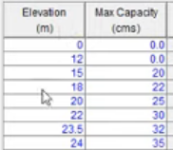

**Uncontrolled discharge**

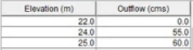

**Flood control:**

Maximum discharge: 60m3/s

**Conservation:**

Elevation: 10m

Discharge: 5m3/s

**Inactive Reservoir:**

Elevation: 5m

Reservoir Initial conditions (Lookback):

Elevation: 10.5m

Controlled discharge: 0m3/s

Uncontrolled discharge: 0m3/s

**Time-Series in CP1 and CP2**

* Rows 1 and 23 of DSS File